Batch Processing for Printing.

Batch Processing is for executing a series of jobs for the order created for Printing.

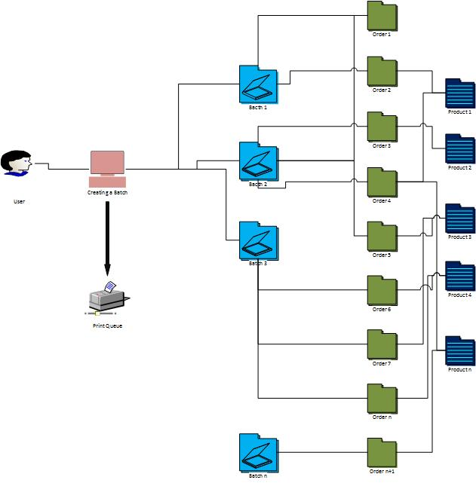

Algorithm:
- Get the maximum count to be placed for the batch.
- Get the batch name/number.
- Select the product.
- Display the total quantity ordered for the product.
- In the grid, display the orders pending for batching for the selected product along with the ordered quantity.
- Enable for choosing multiple product.
- When more than one product is chosen , the quantity of the chosen product must be displayed.
- The grid must display the orders pending for batching for the selected products along with their ordered quantity.
- Enable combining of orders for batching.
- Validate if the combined ordered quantity of a single product/multiple product is equal to the quantity set for batching in step 1.
- Create the batch.
- Once the batch is created the total ordered quantity for the product must be updated for next batching.

Validation:
- The ordered quantity can be the actual quantity ordered or the number of card size for the ordered product.
- This need to be differentiated while placing orders.

